<https://www.okx.com/learn/aave-compound-defi-lending>

# Aave vs Compound: A DeFi Lending Platform Comparison



OKX Learn

2023.01.22

Share

copy

[DeFi](https://www.okx.com/learn/tag/defi)[Stablecoins](https://www.okx.com/learn/tag/stablecoins)

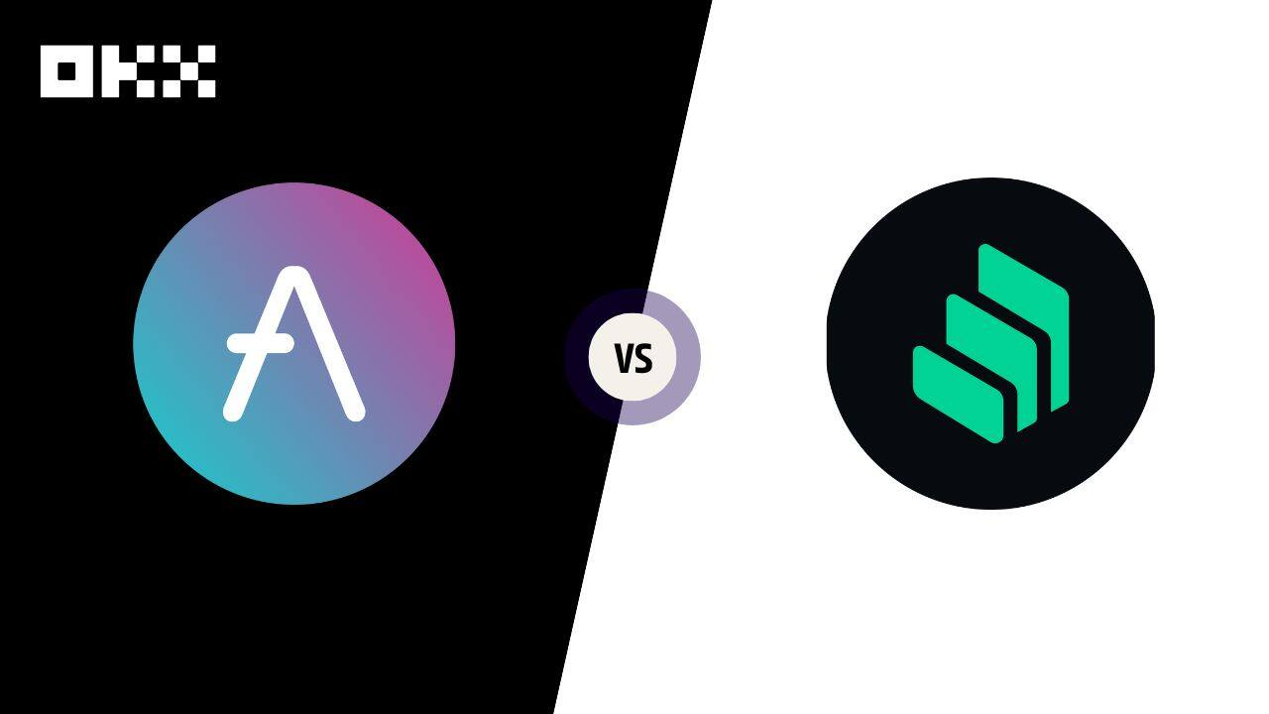

[Decentralized finance (DeFi)](https://www.okx.com/learn/defi-explained) has taken the crypto world by storm, with lending platforms emerging as popular use cases. Two of the most well-known lending platforms in the DeFi space are Aave and Compound. So how do Aave and Compound compare?

[Aave](https://www.okx.com/markets/prices/aave-aave) and [Compound](https://www.okx.com/markets/prices/compound-comp) allow users to lend and borrow various cryptocurrencies, but each has distinct strategies and approaches. For example, Aave allows flash loans to be taken and repaid within a single transaction block. Compound, on the other hand, has a unique token-based governance system that gives token holders a say in the platform’s direction.

## How Does DeFi Lending and Borrowing Work?

DeFi lending and borrowing is a new financial system that allows users to borrow money without a traditional financial institution. The DeFi lending and borrowing process is facilitated through smart contracts on blockchain networks, allowing decentralized lending protocols to be created.

One of the key features of DeFi lending and borrowing is that it provides for the creation of lending pools. These pools are created by users depositing their assets into a smart contract, making those assets available for other users to borrow. The interest rate for borrowing is determined by the supply and demand of the assets in the pool. So, for example, if there is a high demand for a particular asset, the interest rate for borrowing that asset will be higher.

## What Is Aave?

[Aave](https://www.okx.com/learn/what-is-aave) is a decentralized lending platform built on the Ethereum blockchain. It allows users to lend and borrow various cryptocurrencies, including Ethereum and other ERC-20 tokens. Aave is unique because it provides flash loans, which can be taken and repaid within a single transaction block. This facilitates new use cases and financial strategies that are impossible on traditional lending platforms.

Aave has two primary governance tokens: aToken and the “AAVE” token. The aTokens (Aave token) is a type of ERC-20 token representing a user’s deposit in a specific lending pool. For example, if a user deposited 1 ETH into the Ethereum lending pool, they would receive an aETH token representing their deposit. The aTokens can be traded on various cryptocurrency exchanges and used to earn interest on the deposited assets.

The “AAVE” token is the platform’s governance token. Holders of the AAVE token can [vote on changes](https://docs.aave.com/aavenomics/ecosystem-overview) to the platform, such as adding new assets to the lending pools or changing interest rates. They also receive a portion of the platform’s transaction fees, incentivizing holders to participate actively in its governance.

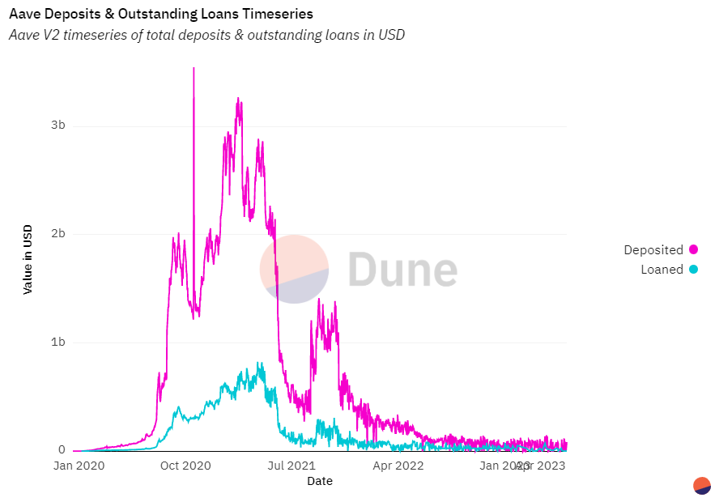

## How Do Aave Flash Loans Work?

[Aave flash loans](https://www.okx.com/learn/aave-flash-loan-tutorial) allow users to borrow assets without collateral for a very short period, usually within a single transaction block. It’s important to note that flash loans are high risk and high reward and should be used with caution. Flash loans are available only on the Ethereum mainnet and not on other networks.

## Pros of Aave

Aave offer several advantages over traditional finance platforms. Here are a few of the main pros of Aave:

* **Flash loans:** Aave offers flash loans, which can be taken and repaid within a single transaction block. This allows for financial strategies that may not be possible on traditional lending platforms.
* **Multiple assets:** Aave supports the [lending and borrowing](https://www.okx.com/learn/aave-lend-borrow-tutorial) of multiple assets, including Ethereum and other ERC-20 tokens. This allows users to diversify their portfolios and access a broader range of assets.
* **No credit check:**Aave does not require a credit check to lend or borrow assets. This allows users who may not have access to traditional lending options to participate.
* **Lending pools with dynamic interest rates:** Aave’s lending pools are determined by the supply and demand of the assets in the pool. This allows for a more efficient market, and borrowers can access loans at the most competitive interest rates.
* **Decentralized governance:** Aave’s decentralized and community-driven governance allows token holders to vote on changes to the platform. This allows for a more transparent and democratic decision-making process.
* **aTokens:** Aave’s ERC-20 tokens, aTokens, represent a user's deposit in a specific lending pool. The aTokens can be traded on various cryptocurrency exchanges and can be used to earn interest on the deposited assets.
* **Security:** Aave is built on the Ethereum blockchain, which is considered secure and robust. Additionally, reputable third-party security firms have audited the smart contracts that power Aave. This helps to ensure the safety of user assets.

## Cons of Aave

Like any platform, Aave also has some cons. Here are a few of the main cons of Aave:

* **Ethereum network dependence:** Aave is built on the Ethereum blockchain, which means it depends on the Ethereum network. This can lead to slower transaction times and higher gas fees during periods of high network congestion.
* **Liquidity risk:** Aave’s lending pools are determined by the supply and demand of the assets in the pool. A lack of supply or demand for a particular asset could lead to a lack of liquidity. This could make it difficult for users to borrow or lend that specific asset.
* **Lack of regulation:** Aave is a decentralized platform that operates outside traditional financial regulations. This means there is a lack of oversight and protection for users in case of any issues.

## What Is Compound Finance?

Compound Finance, like Aave, is a decentralized borrowing and lending platform built on the Ethereum blockchain. The platform allows users to deposit their assets, earn interest on their deposits, and borrow assets from the lending pools.

One of the unique features of Compound is its token-based governance system. The platform’s token, the “COMP” token, gives holders a say in the direction of the platform. For example, holders can vote on adding new assets to the lending pools or changing interest rates. This allows for a decentralized form of governance, where the community determines the direction of the platform.

Interest rates for borrowing assets are dynamic and determined by the supply and demand of the assets in the lending pools. The rates are adjusted automatically in response to supply and demand changes, allowing for a more efficient market. This also benefits borrowers as they can access loans at the most competitive interest rates.

Compound also has a feature called “cTokens,” which are ERC-20 tokens that represent a user’s deposit in a specific lending pool. For example, if a user deposited 1 [ETH](https://www.okx.com/markets/prices/ethereum-eth) into the Ethereum lending pool, they would receive a cETH token representing their deposit. The cTokens can be traded on various cryptocurrency exchanges and can be used to earn interest on the deposited assets.

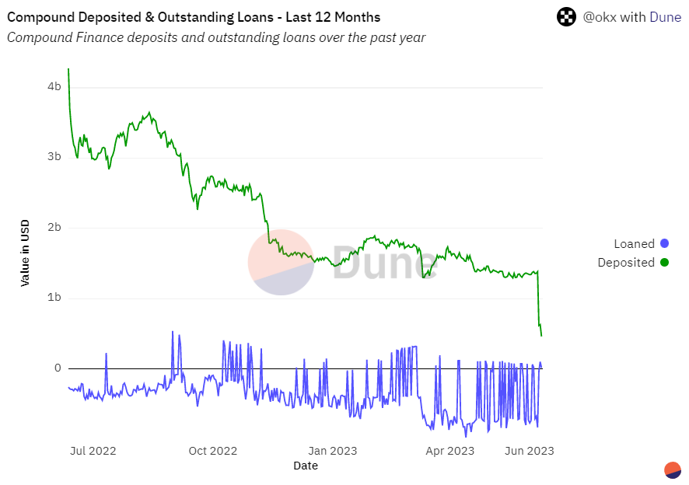

## Pros of Compound finance

Here are a few of the main pros of Compound Finance:

* **Decentralized governance:** Compound Finance has a token-based governance system where token holders can vote on the direction of the platform. This allows for a more transparent and democratic decision-making process.
* **Dynamic interest rates:** The interest rates for borrowing assets are dynamic and determined by the supply and demand of the assets in the lending pools. This allows for a more efficient market, and borrowers can access loans at the most competitive interest rates.
* **Multiple assets:** Compound Finance supports lending and borrowing of multiple assets, including Ethereum and other ERC-20 tokens. This allows users to diversify their portfolios and access a wider range of assets.
* **cTokens:** These ERC-20 tokens represent a user’s deposit in a specific lending pool. The cTokens can be traded on various cryptocurrency exchanges and used to earn interest on the deposited assets.
* **High liquidity**: Compound’s pools of assets are highly liquid, allowing users to borrow and lend easily and making it easy to find a counterparty.
* **No credit check:** Compound Finance does not require a credit check to lend or borrow assets. This allows users who may not have access to traditional lending options to participate in the platform.

## Cons Compound finance

Here are a few of the main cons of Compound Finance:

* **Risk of impermanent loss:**Compound Finance is a market-making protocol that allows users to borrow and lend assets to earn interest. When lending assets, the user is exposed to the risk of impermanent loss, which can occur when the price of the borrowed asset changes quickly.
* **Complexity**: Compound Finance has a more complex system than other lending platforms, which may make it more difficult for new users to understand.
* **Smart contract risk:** Compound Finance is built on smart contracts, and like any smart contract, there is a risk of bugs or errors that could lead to the loss of user assets.

## Aave vs. Compound: Which Is Better?

Aave and Compound are both decentralized lending platforms that allow users to lend and borrow a variety of different cryptocurrencies. However, both platforms have unique features and functionalities, and the best platform for users will depend on their specific needs and preferences.

Aave is best for users looking for flash loans, which can be taken and repaid within a single transaction block. Additionally, Aave has a decentralized governance system where token holders can vote on changes to the platform.

Compound is best for users looking for a token-based governance system where token holders can vote on the direction of the platform. It also has dynamic interest rates determined by the supply and demand of the assets in the lending pools.

Compound also has higher liquidity as it has more assets in the lending pools. The platform also has more market participants, so it’s easier to find a counterparty. However, Aave is also a well-established platform with good liquidity.

In terms of security, both platforms are built on the Ethereum blockchain. Reputable third-party security firms audit both. However, since both are decentralized platforms that operate outside of traditional financial regulations, there is a lack of oversight and protection for users.

**Aave vs. Compound: A Comparison**

|  |  |  |
| --- | --- | --- |
| **Feature** | **Aave** | **Compound Finance** |
| Flash loans | Yes | Yes |
| Decentralized governance system | Yes | Yes |
| aTokens (ERC-20 tokens representing user’s deposit) | Yes | Yes |
| Flash loans availability | Ethereum mainnet only | No |
| Insurance | No | No |
| Smart contract risk | Yes | Yes |
| Fiat currency support | No | No |
| Platform token | aToken and the “AAVE” token | cTokens |

## Aave and Compound Stands Out in the DeFi Space

Aave and Compound are both popular decentralized lending platforms that allow users to lend and borrow a variety of different cryptocurrencies.

In the end, both platforms offer a wide range of options and opportunities for users to lend and borrow crypto assets in a decentralized way. Both stand out in the DeFi space and are likely to grow in significance and popularity in years to come.

## FAQs

### What Is the Difference Between Aave and Compound?

Aave offers flash loans, allowing users to borrow assets without collateral for a short period. Compound does not offer flash loans.

Additionally, Aave has a decentralized governance system where token holders can vote on changes to the platform. In contrast, Compound has a token-based governance system, where token holders can vote on the direction of the platform. Compound has dynamic interest rates, while Aave interest rates for loans are fixed.

### Which DeFi Lending Platform Is More Popular, Aave or Compound?

It's difficult to determine which DeFi lending platform is more popular. The popularity of a platform can depend on various factors, such as user sentiment, market conditions, and recent events or updates. Compound is more popular in terms of market capitalization and liquidity, while Aave is known for its flash loans and interest rate switching feature.

### How Do the Interest Rates on Aave and Compound Compare?

The interest rates on Aave and Compound are determined differently. Aave has a fixed interest rate for loans, which means the rate is set by the protocol and will not change over time. Compound, on the other hand, has dynamic interest rates, which means the interest rate is determined by the supply and demand of the assets in the lending pools. The interest rates on Compound are determined algorithmically, and they can change over time. As a result, the interest rates on Compound are generally higher than those on Aave, as they are more responsive to market fluctuations and demand.

### What Are the Key Features of Aave and Compound?

Aave is a decentralized lending platform that offers flash loans, allowing users to borrow assets without collateral for a short period. It also has a decentralized governance system where token holders can vote on changes to the platform.

Compound is a decentralized lending platform with a token-based governance system, where token holders can vote on the direction of the platform. It has dynamic interest rates determined by the supply and demand of the assets in the lending pools.